- 单项选择。
( )1.— —He’s my father.[来源:学科网ZXXK]
A.Who’s that girl? B.Who’s that man? C.Who’s that woman?
( )2.This is my brother. is nine.
A.He B.She C.They
( )3.—Who’s this woman? — [来源:Z.xx.k.Com]
A.He’s my brother. B.He’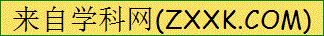s my father. C.She’s my mother.
( )4.—Is this ? —No, she isn’t.
A.your father B.your brother C.your sister
( )5. name is Wang Bing.
A.His B.She C.He

